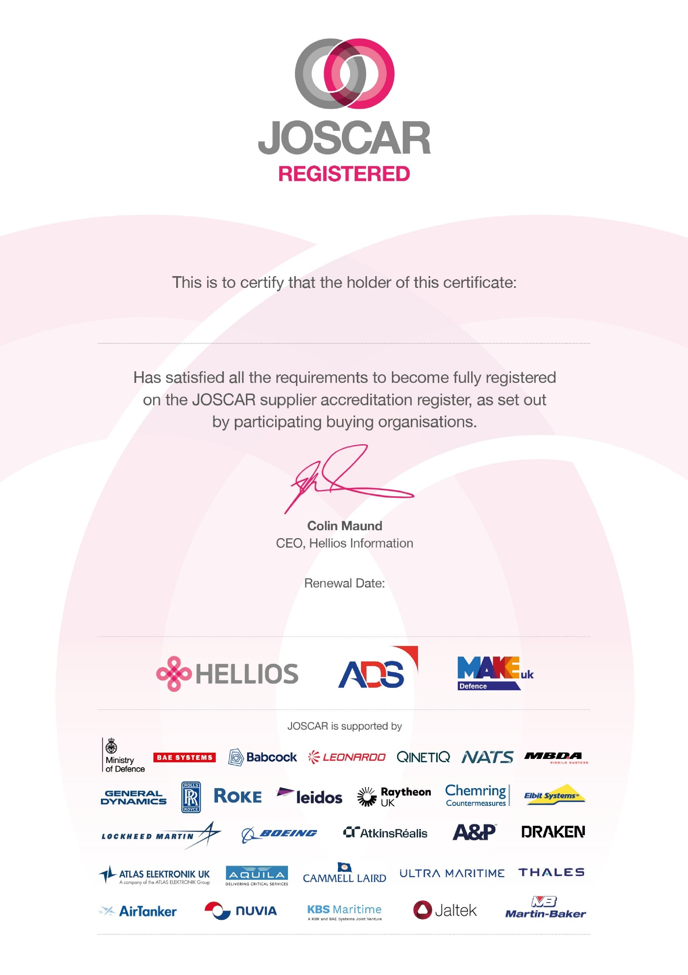
16
July
2026
Pritex Limited

